# The Battle of Neighbourhoods

# Maurizio Scibilia

## Introduction

Bangkok is the capital of Thailand, in the Asian South-East. It has more than 8 million inhabitants and, last data, more than 22 million tourists, per year. An Italian entrepreneur, inspired by the success of Pala Pizza Romana in Asok (Bangkok) has asked us to evaluate areas close (in a radius of 500 meters) to BTS stops and check the competitors, specifically around two stops in spots full of expats and considered trendy: Ari and Thong Lo. The restaurant they want to open is a traditional Pizza Place, offering also slices of pizza, gelato (the Italian high-quality version of ice-cream) and coffee specialties like espresso and cappuccino. We will use Folium Maps to check the areas, and the Foursquare API, in order to do so, eventually scraping TripAdvisor to check the reviews of selected competitors. Clearly, this is a simplified project, considered that the choice is just between two areas.

## Data

We are going to massively use the Foursquare API, to check the venues in specific areas of Bangkok. We will use the Folium library to show them. We will also be scraping TripAdvisor to check reviews on the two main pizza places in the two neighbourhoods, producing a wordcloud.

## Exploratory Data Analysis

Our EDA is gonna be based on the Folium maps and on the Foursquare data. We are analysing different areas and trying to see which one fits more the requests of the potential investor. The Folium maps allow us to check distances and location and, even though looking at a map is cannot be considered as being there in person, we can find many information useful for such an analysis.

### Map of Bangkok Districts

First of all, Bangkok is split in districts, and they are 50. Looking at the Wikipedia page <https://en.wikipedia.org/wiki/List_of_districts_of_Bangkok>, we scrape it, to build a table containing, among the other things, its names, population, Thai names, latitudes and longitudes. The web scraping, in this case, is performed directly with through the *pandas* library, that has a method *read_html*. Then, using this data, we can build the Bangkok map, with the location of every district. The two districts where the two BTS Stops are located, Khlong Toei (Thong Lo, South) and Phaya Phai (Ari, North), are marked in red.

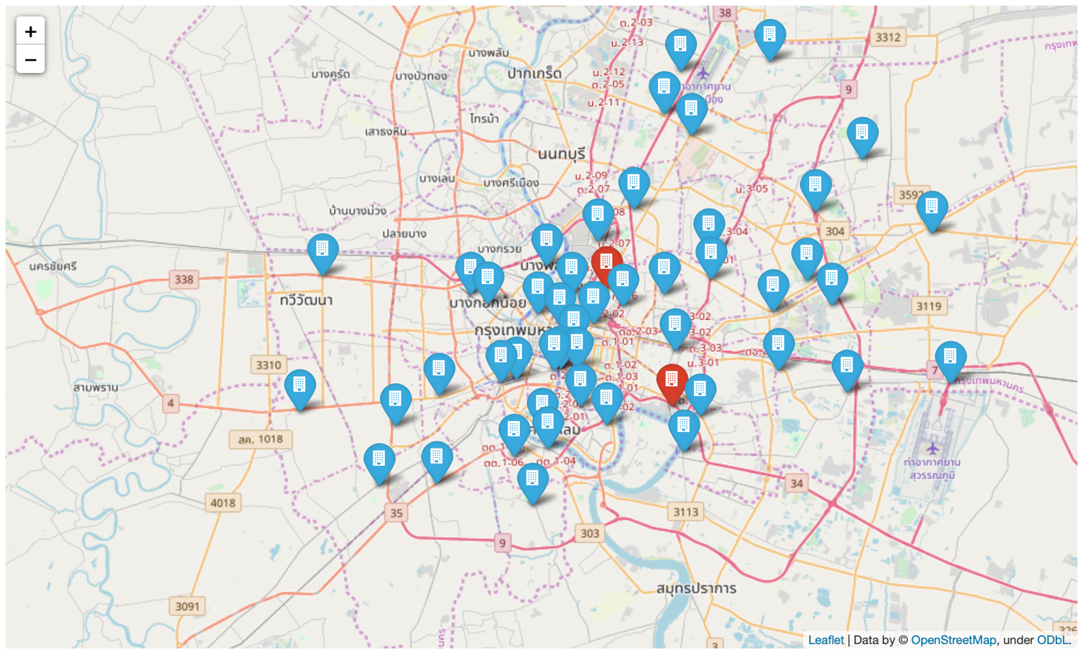

### **Close to the Ari BTS Stop**

For this and for the next part, we are going to use the Foursquare API. We’ll use the venues category to select the venues we aim to find, the BTS Stops latitudes and longitudes to restrict our research to an area of 500 meters. We will use the ‘Pizza Place’ category to select restaurants serving pizza:

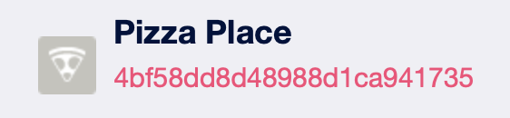

We’ll use the Ice-Cream Shop category, adding the word ‘gelato’ to a query to select places serving gelato:

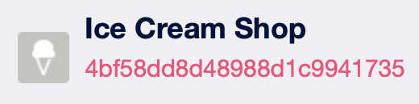

We’ll use the Coffee Shop category, adding the word ‘espresso’ to a query to select places serving espresso:

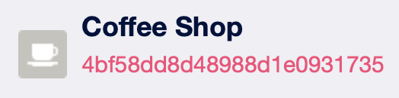

Pizza (rating over 6/10, Italian-like name)



Gelato

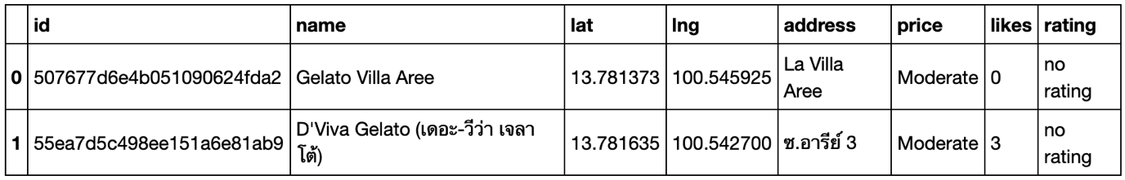

Espresso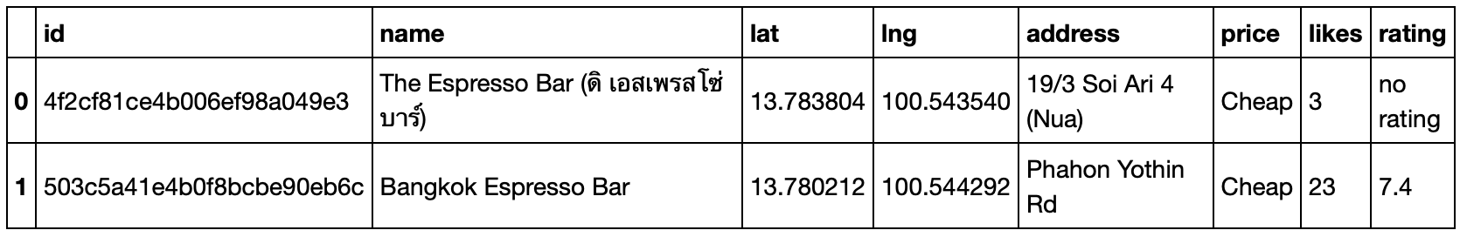

Map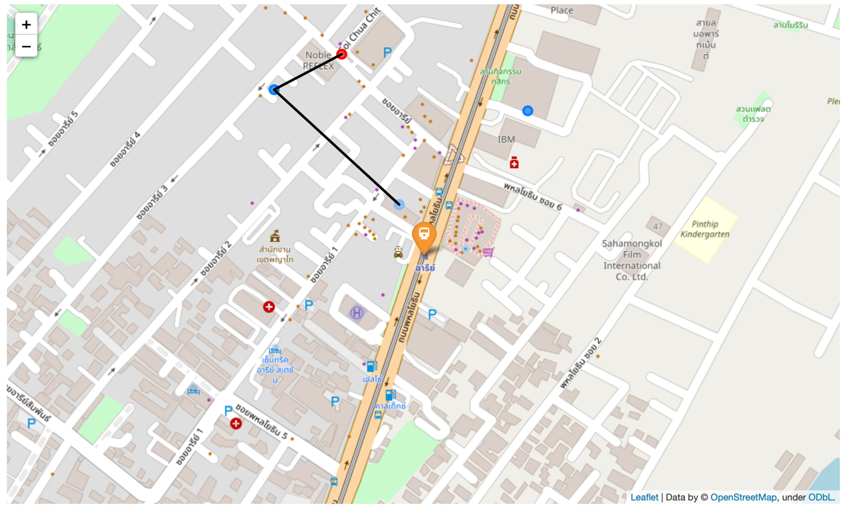

### **Close to the Thong Lo BTS Stop**

Pizza (rating over 6/10, Italian-like name)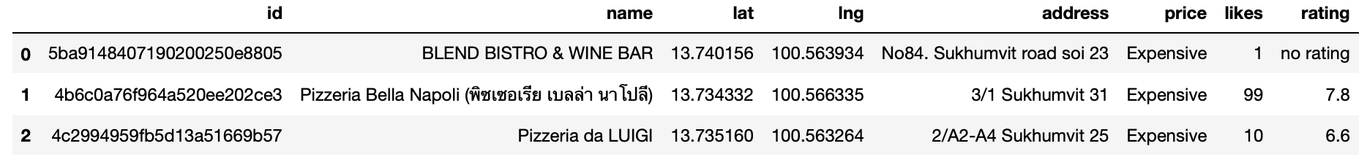

the first one, Blend Bistro & Wine Bar, has not an Italian name, but we keep it

Gelato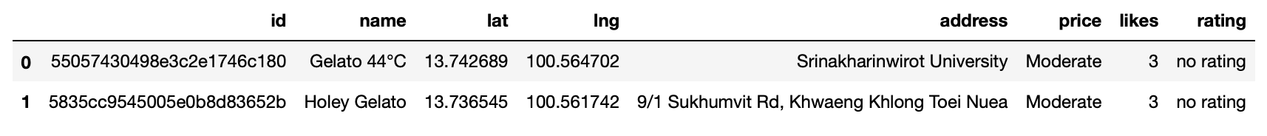

There are no coffee shops with the word espresso in their name

Map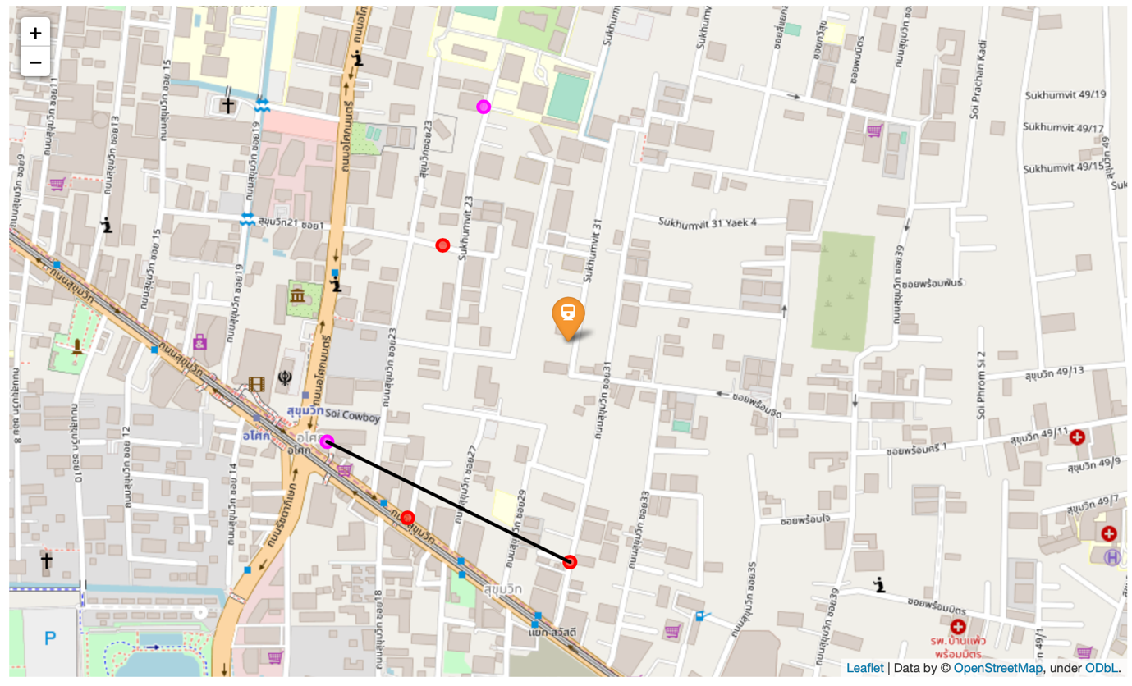

### **Tripadvisor Reviews WordCloud – Pizzeria Bella Napoli**

For this part, we used *BeautifulSoup*, a library to do web scraping. We select a starting page, and then we follow the flow of the reviews till the end. In this way, we are able to get all the reviews and to put them into a dataframe. Let’s see its head: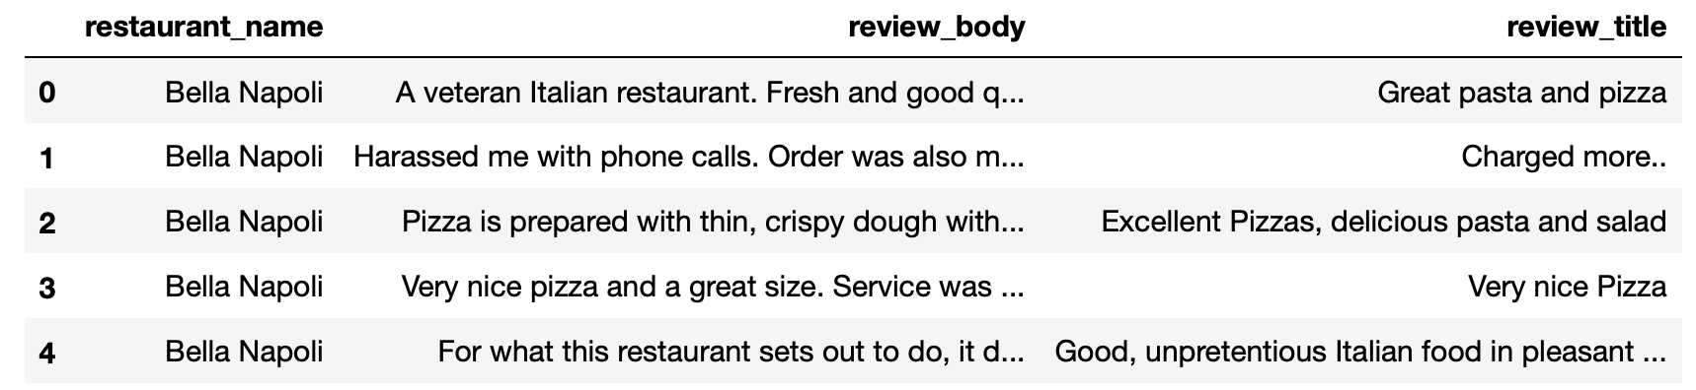

TripAdvisor has 472 reviews of this restaurant, two of them praising their coffee. We join the reviews, to produce a wordcloud. The *WordCloud* library analyses a text and shows the words dimensions directly related to their frequency. This way, we can, in a single glance, check the buzz.

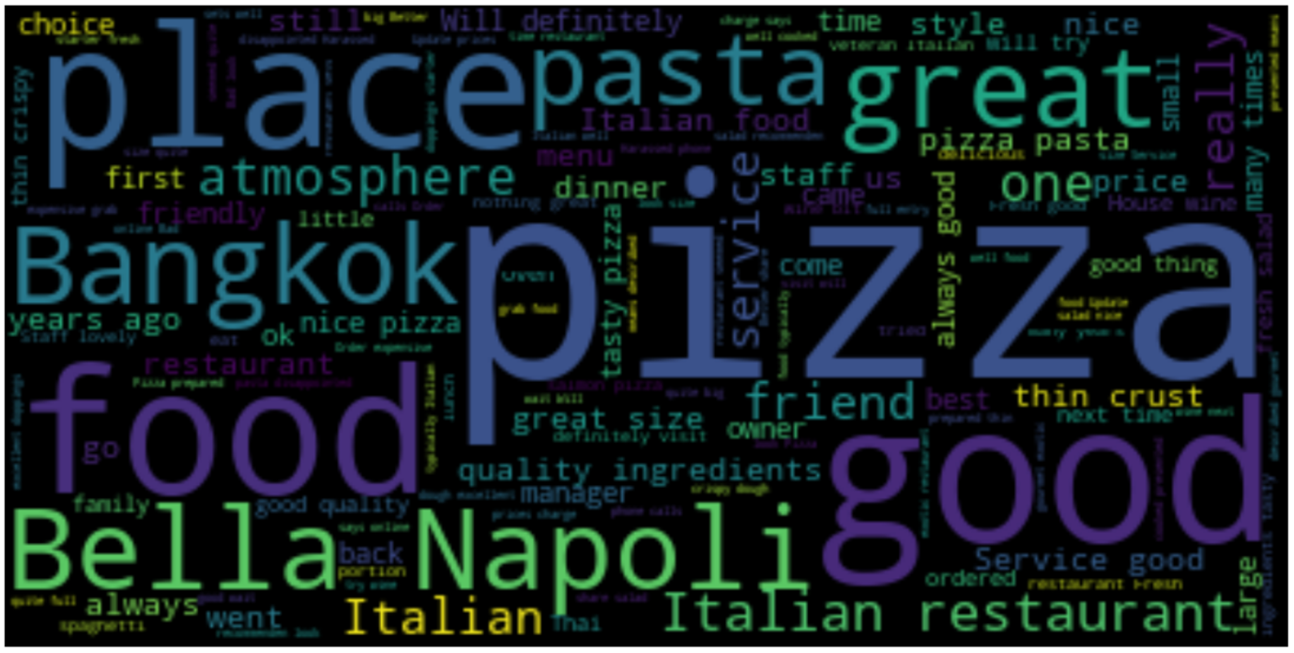

We produced also the wordcloud for Basilico Pizzeria, close to Ari, but there are only six reviews, and this is not a sufficient number to get anything.

## Conclusions

In summary, Ari offers gelato and espresso and a Pizza Place that, with a rating of 7.1/10, has only 6 reviews.

*Pizzeria Bella Napoli*, close to the Thong Lo BTS Stop, has a higher rating of 7.8/10, 472 reviews, with two of them directly talking of coffee, that in an Italian restaurant probably means 'espresso'. The area offers other two pizza places, one of them with an Italian name (Pizzeria Da Luigi).

After analysing these reviews, we might think that actually the Ari BTS stop could be a good choice as well.

In both areas, for different reasons, the competition doesn't look invincible!

* Ari: The best and close pizza place, *Basilico*, has less reviews and a lower rating, but closer to the BTS stop.
* Thong Lo: *Pizzeria Bella Napoli* is appreciated, but it's not so close. There are two other pizza places.

Both of these places don't offer slices of pizza.

I would still suggest Thong Lo, cause the competition is not too close, but just if we can open a place really close to the BTS Stop.